**ECEN 5023 FINAL PROJECT**

**SENSOR CONTROLLED HOVERBOARD**

**OVERVIEW:**

1. A mobile hoverboard prototype, on which the user can stand and can control its speed and direction by shifting body weight. It is connected to the Atmel Smart app to send crash/ speed notifications
2. The ambient light sense can sense dark and can turn on LED on Leopard Gecko.( mimicking headlights on a vehicle)
3. The Capactive sensor can be used to turn the hoverboard on or off.
4. I2C accelerometer is used to detect tilt and decide speed (PWM duty cycle) of hoverboard.
5. Two pressure sensors are used to detect/change direction
6. Ultrasonic proximity sensor is used to detect obstacle and send alert on phone
7. Internal temperature sensor will be analogous to monitoring MOTOR temperature.

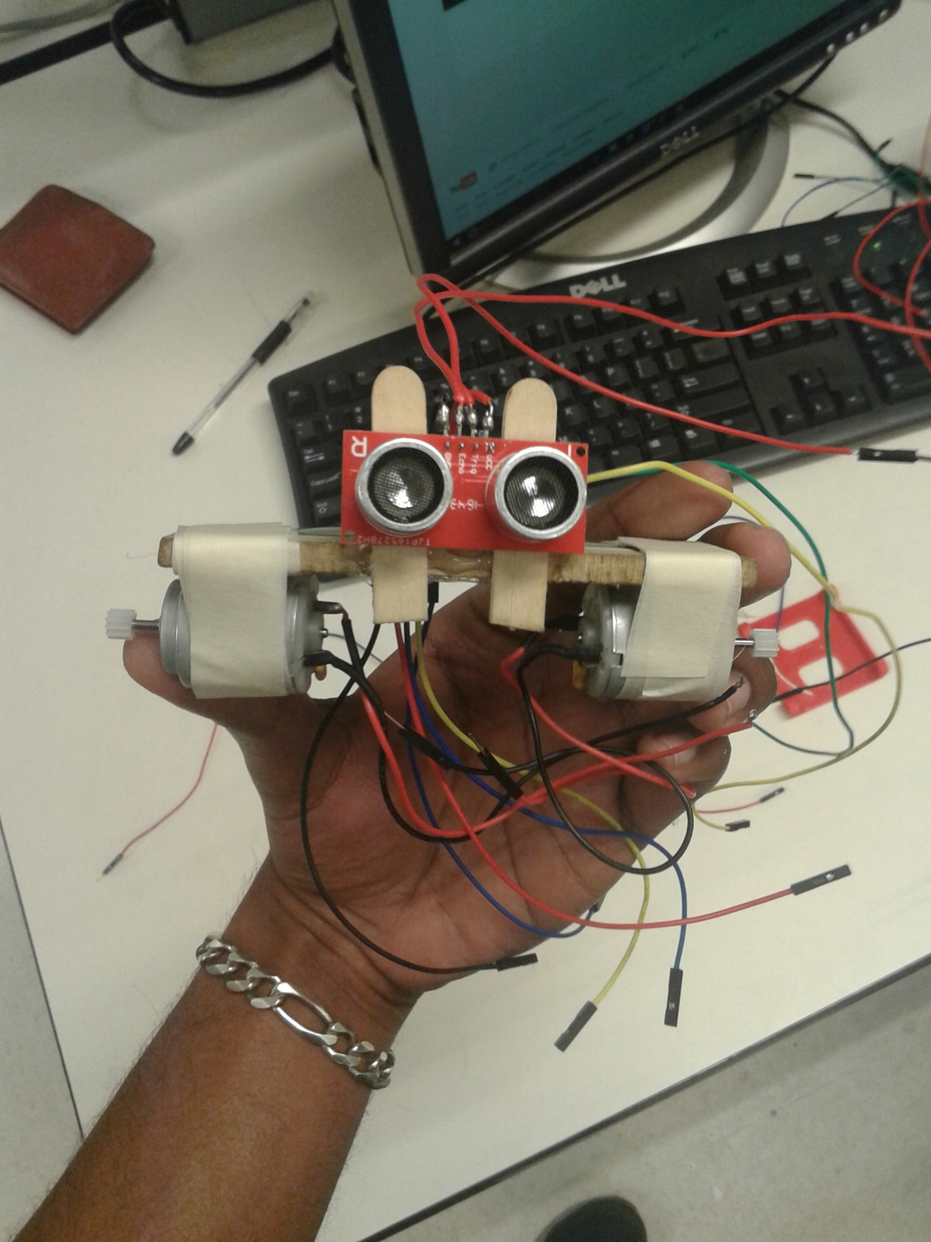

**PROBLEM ADDRESSED:**

1. Added safety (crash notification, temperature alerts and automatic stopping if approaching a wall)
2. Added control of speed and direction
3. More autonomous(automatic darkness detection, automatic stopping)
4. Riding data can be obtained and displayed on the phone

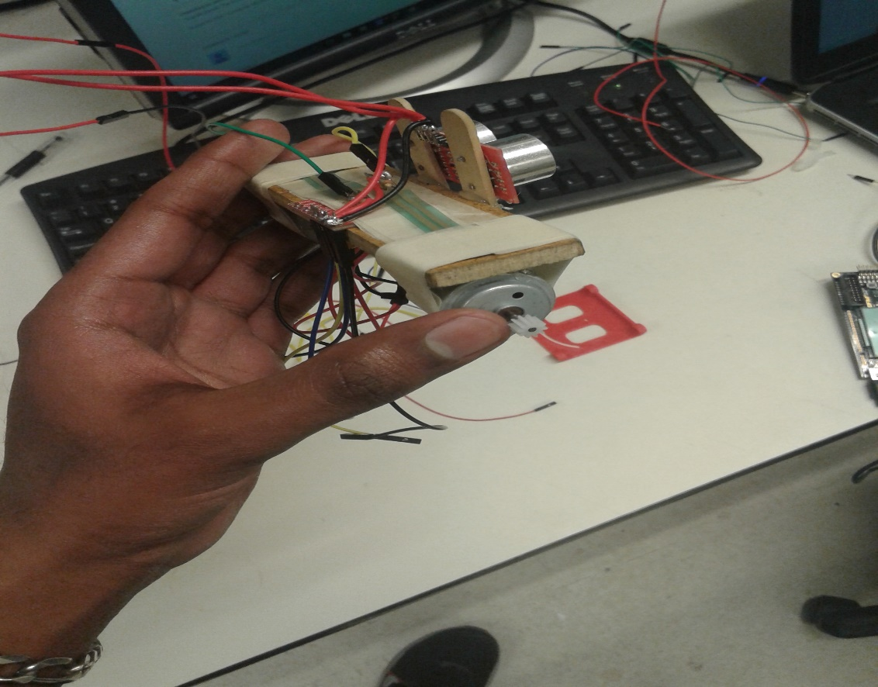

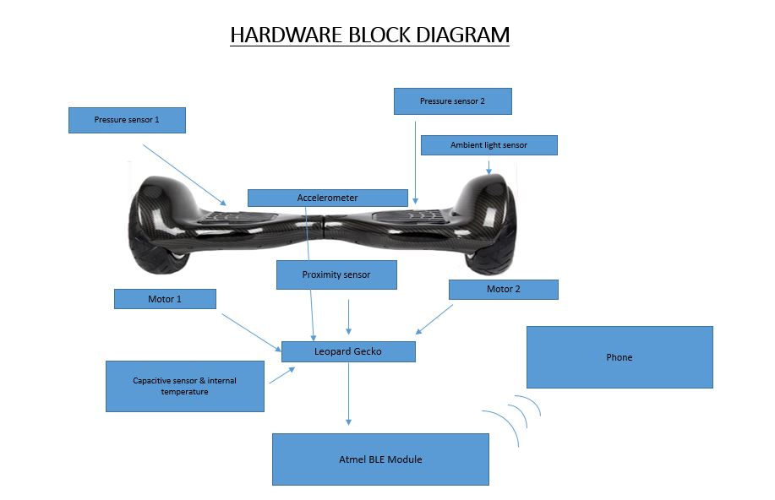

**KEY COMPONENTS**

* 2 brushed dc Motors
* 2 Pressure sensors (force sensitive resistors)
* Ambient light sensor
* 1 6-AXIS ACCELEROMETER+MAGNETOMETER
* Leopard Gecko Capacitive sensor
* Ultrasonic / proximity sensor
* Internal temperature sensor
* Atmel SAMB11 Xplained Board
* Motor driver H-bridge

**SOFTWARE FLOW ORGANIZATIONAL CHART:**

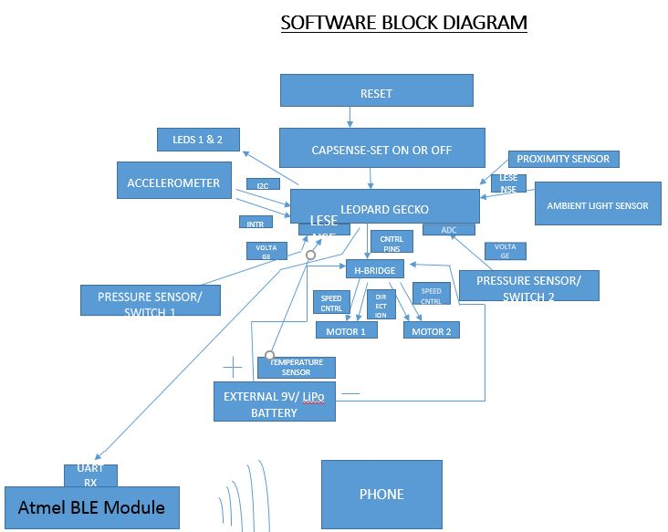

**LIST OF COMMANDS USED IN THE PROGRAM:**

1. As the prototype is aimed to be autonomous, the expected user commands are minimal. However, some of the critical commands that the user could input are.
2. Pressing CAPSENSE to turn the system ON or OFF.
3. Blocking the path of the ultrasonic sensor to simulate a block in the path and turn off the motors.
4. Tilting the motors in forward and reverse directions to change the speed and direction of the motors
5. Pressing one or two FSR to make one or two motors rotate
6. Covering the ambient light sense to simulate darkness and turn on an led.

**SOFTWARE OVERVIEW:**

* The sensor modules will be programmed to control the motor and communicate with the Leopard Gecko
* The main focus of the project would be to ensure seamless communication between the various modules and thereby enhancing the overall functionality

**TRIGGER POINTS USED IN THE CODE:**

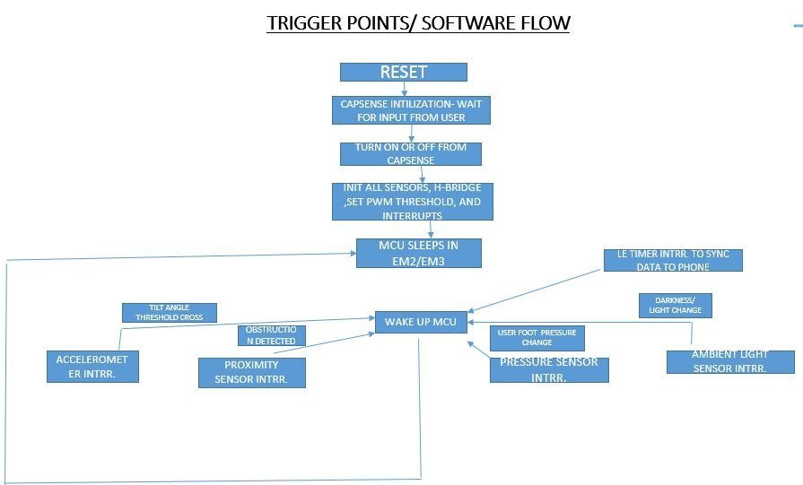

**PLANNED DEVELOPMENT SCHEDULE:**

1. Accelerometer working with I2C
2. Configuring accelerometer interrupts on various angles
3. Exploring use of magnetometer
4. Motor PWM control using LE Timer PWM module  
   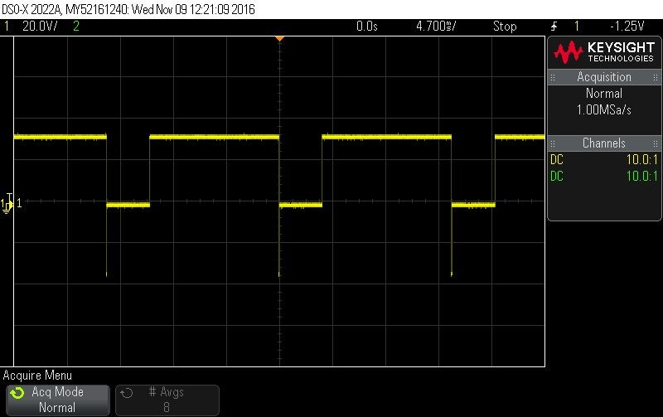
5. Integrating accelerometer interrupts with motor speed control
6. Changing motor direction
7. CAPSENSE configuration
8. Ambient light sensor using LESENSE
9. Adding second profile to BLE

10.Force sensitive resistor control using LESENSE

**DIFFICULTIES ENCOUNTERED DURING THE PROJECT:**

1. CONFIGURING I2C INTERRUPT FOR ACCLEROMETER- This was harder than expected as the accelerometer is not designed to detect tilt motions to that precision. Instead a gyroscope in the place of the accelerometer would have been easier to integrate.
2. SHARING PWM PINS FOR LIGHT SENSE LED- PD6 was initially used as PWM output pin using the LETIMER. When the LEDs were used too, there were some undefined effects seen such as the LEDs blinking whenever there was a PWM. It was later found the reason that PD6 was also the LED excite port pin. Hence, the PWM output was changed to a different pin to resolve this issue.
3. CONFIGURING ULTRASONIC SENSOR ON LESENSE CHANNEL- the ultrasonic sensor is configured to be ON only when the PWM is received on the H bridge. Hence, the trigger pin on the ultrasonic sensor is connected to the PWM pin on the H bridge. This meant that the conventional method of using the ultrasonic sensor could no longer be possible. Instead, the number of echoes received are measured and the distance is gauged.
4. INTEGRATION OF 8 SENSORS FOR SEAMLESS FUNCTIONALITY USING INTERRUPTS- the hoverboard is completely autonomous. This means that all the sensors and the motors should be working independently without any user intervention. The initial setup of bringing together all the elements and setting them up was tedious.
5. HARDWARE SETUP TO RESEMBLE A HOVERBOARD- The prototype setup should resemble a hoverboard for it to be demoed more efficiently. Hence, putting together the 8 sensor, H bridge and the two motors and making it resemble a hoverboard was difficult. Glue guns, tape and popsicle sticks were used to make it happen.
6. DIFFICULTIES INTEGRATING MULTIPLE PROFILES ON BLE- To capture and reflect all the sensor data on the BLE using the smartphone, we needed a minimum of 3 profiles. The initial idea of the project also included processing all the rider data and giving some feedback on the rider’s performance. This was not achieved at the later stages due to the lack of time. We ended up implementing three profiles on the BLE namely temperature, heart rate and the battery profile.

**FUNCTIONALITY OF PROJECT:**

THIS PROTYPE REPLICATES A FULLY FUNCTIONAL HOVERBOARD WITH ALL THE FEATURES THAT A CONVENTIONAL HOVERBOARD HAS. IN ADDITION THERE ARE ADDED FEATURES SUCH AS ULTRASONIC SENSOR, REAL TIME UPDATES ON THE SENSOR DATA ETC.,

MULTIPLE SENSORS CAN BE USED TO CONTROL VARIOUS ASPECTS OF HOVERBOARD NAMELY SPEED, DIRECTION, CRASH DETECTION AND AMIENT LIGHT. USER CAN VIEW THESE SENSOR DATA ON BLE ENABLED PHONE.

**TEMPERATURE**: MAGNETOMETER TEMPERATURE MEASUERED AND UPDATED ON BLE HEALTH TEMPERATURE PROFILE

**PWM AND DIRECTION**: DATA FROM ACCELEROMETER CAN BE DISPLAYED ON HEART RATE PROFILE.

**AMBIENT LIGHT SENSOR:** LEOPARD GECKO LESENSE AMBIENT LIGHT SENSOR DATA CAN BE USED TO LIGHT LEDS

**FSRS:** FORCE SENSITIVE RESISTORS CAN BE USED TO DETECT WHICH DIRECTION THE USER WANTS TO TRAVEL.

**CAPSENSE:** TO POWER THE SYSTEM ON OR OFF

**LESSONS LEARNED:**

1. Learnt how to interface various sensors seamlessly at low energy level using interrupts.
2. To send multiple sensor data across different BLE profiles.
3. Could have focused more on the BLE side (adding more profiles), give rider ratings, implement two-way communication
4. Figuring out the hardware setup to resemble a hoverboard.

**WOW FACTOR**

* Total of eight sensors used together.
* All the sensor and other functionality in the system is interrupt driven with an idle sleep mode in EM2.
* Controlling two motors using h bridge to change direction and speed
* Interrupt driven tilt detection using a 6 axis motion sensor.
* Trigger points to start and stop the motor- additional user safety
* 3 profiles to display data and crash detection/ how close an object is to the rider.